**Numpy Lab Exercises**

**Exercise 1: Create a 4X2 integer array and Prints its attributes**

**Note:** The element must be a type of unsigned int16. And print the following Attributes: –

* The shape of an array.
* Array dimensions.
* The Length of each element of the array in bytes.

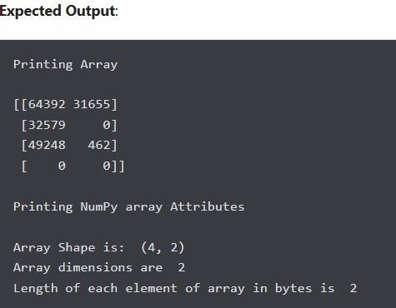

#### Exercise 2: Create a 5X2 integer array from a range between 100 to 200 such that the difference between each element is 10

**Expected Output**:

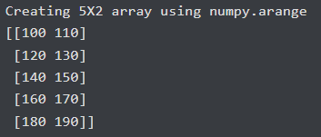

#### Exercise 3: Following is the provided numPy array. Return array of items by taking the third column from all rows



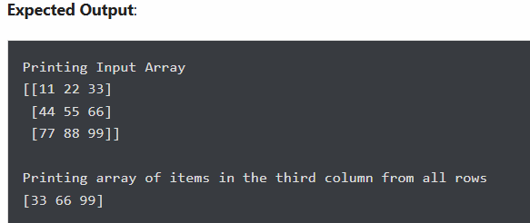

#### Exercise 4: Return array of odd rows and even columns from below numpy array

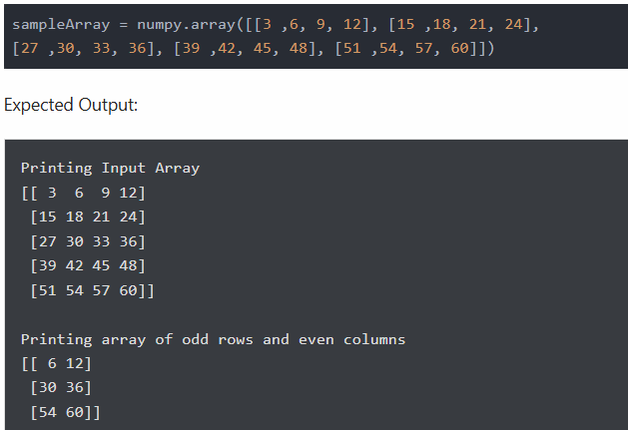

#### Exercise 5: Create a result array by adding the following two NumPy arrays. Next, modify the result array by calculating the square of each element

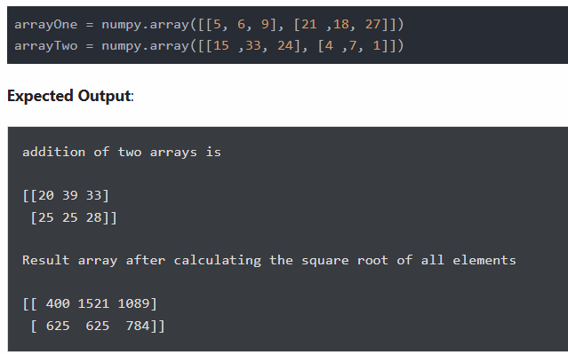

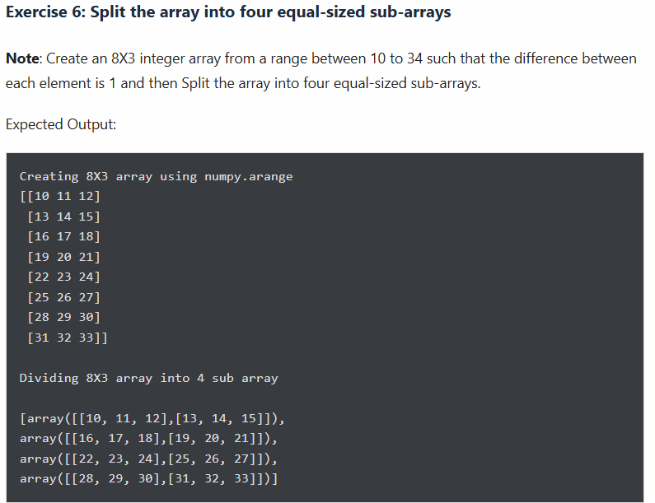

**Exercise 7: Sort following NumPy array**

* **Case 1**: Sort array by the second row
* **Case 2**: Sort the array by the second column

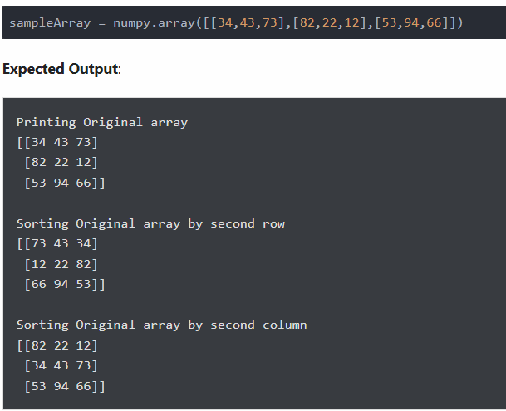

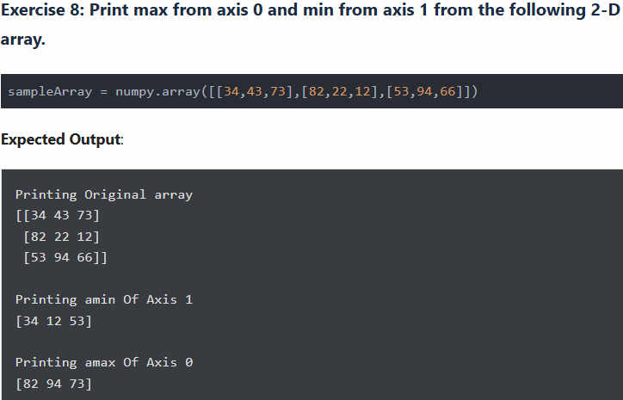

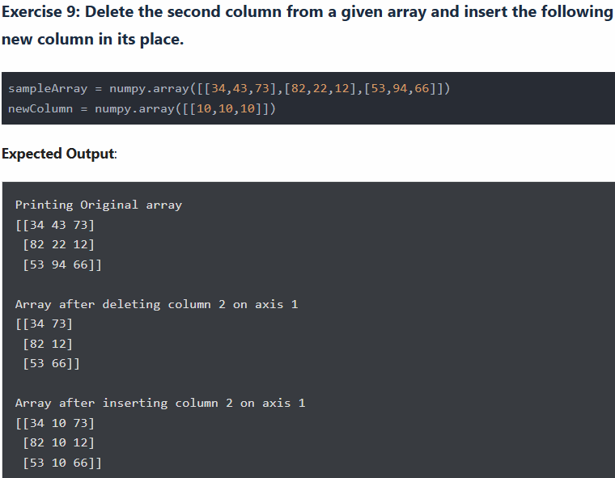

#### Exercise 10: Create two 2-D arrays and perform operation as shown below:

